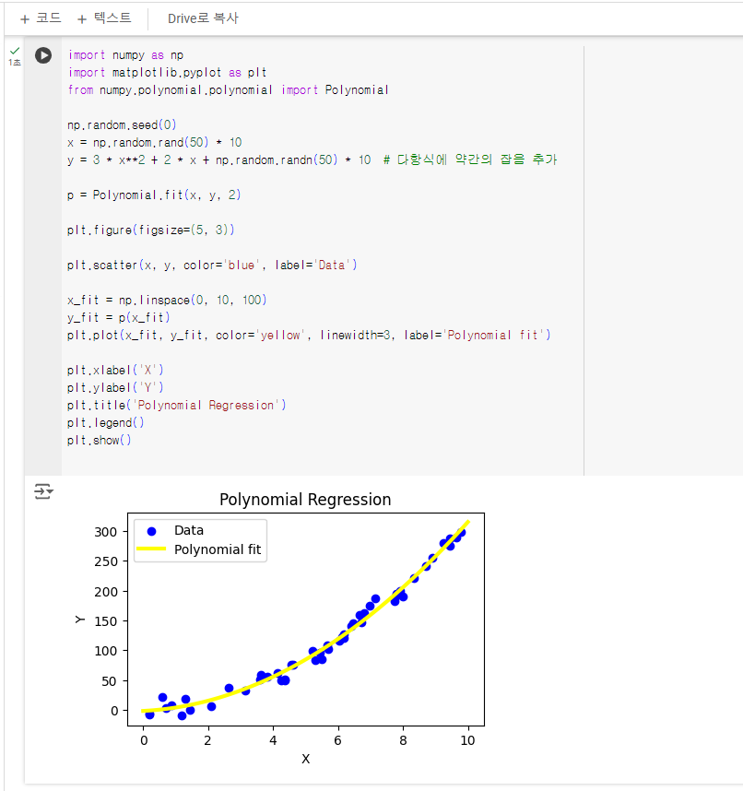

7주차 과제

import numpy as np

import matplotlib.pyplot as plt

from numpy.polynomial.polynomial import Polynomial

np.random.seed(0)

x = np.random.rand(50) * 10

y = 3 * x**2 + 2 * x + np.random.randn(50) * 10 # 다항식에 약간의 잡음 추가

p = Polynomial.fit(x, y, 2)

plt.figure(figsize=(5, 3))

plt.scatter(x, y, color='blue', label='Data')

x_fit = np.linspace(0, 10, 100)

y_fit = p(x_fit)

plt.plot(x_fit, y_fit, color='yellow', linewidth=3, label='Polynomial fit')

plt.xlabel('X')

plt.ylabel('Y')

plt.title('Polynomial Regression')

plt.legend()

plt.show()